Bachelor of Education (Elementary) &

Bachelor of Education (Secondary) STEM

Unit Plan Template

Unit Title: | Forces and Motion | Number of Lessons | 7 | Time  (in weeks): | 10
Name: | Barkha Dhanju | Subject(s): | Science, Art , ADST, Language Arts | Grade(s): | 2

Rationale
This unit is important as it incorporates many different curricular competencies at once. While learning about forces and motions students will be doing many hands-on activities that will allow them to be creative and build things out of certain materials. They will learn how everyday objects move and what forces are used to move them. They will also be using a lot of prediction skills in this unit which will improve their creative thinking and allow them to think beyond the scope. They will also be using various methods to learn about forces and motions so students can get a deeper understanding about the topic.

Overview:
In this unit we will be learning about forces and motions while focusing on a few main topics such as push and pull, speed, gravity, and magnetism. While learning about these topics, we will be doing many hands-on activities that also incorporate art, ADST and language arts. With each topic we will be looking at real life examples, so students are able to see how forces and motions play a part in our everyday lives. We will end this unit with a field trip to the big little science center where they will be able to observe what we learnt in our classroom in a different concept.

CORE COMPETENCIES
Communication | Thinking | Personal & Social
- Students engage in informal and structured conversations in which they listen, contribute, develop understanding and relationships, and learn to consider diverse perspectives  - They present information for many purposes and audiences, and their presentations often feature media and technology. | - Critical thinking  - Students learn to analyze and make judgments about a work, a position, a process, a performance, or another product or act.  - They reflect to consider purpose and perspectives, pinpoint evidence, use explicit or implicit criteria, make defensible judgments or assessments, and draw conclusions.  - Students have opportunities for analysis and critique through engagement in formal tasks, informal tasks, and ongoing activities.  - Students learn to engage in inquiry when they identify and investigate questions, challenges, key issues, or problematic situations in their studies, lives, and communities and in the media.  - They develop and refine questions; create and carry out plans; gather, interpret, and synthesize information and evidence; and reflect to draw reasoned conclusions.  - Critical thinking activities may focus on one part of the process, such as questioning, and reach a simple conclusion, while others may involve more complex inquiry requiring extensive thought and reflection.  - They explore possibilities, develop and reflect on processes, monitor progress, and adjust procedures in light of criteria and feedback.  - Creative thinking  - Students may generate creative ideas through free play, engagement with other’s ideas, or consideration of a problem or constraint, and/or because of their interests and passions  - Students reflect on their creative ideas in order to decide which ones to develop. | - Positive personal and cultural identity  - They explain how they are using their strengths and abilities in their families, their relationships, and their communities.  - Personal awareness and responsibility  - Social responsibility  - Students build and maintain diverse, positive peer and intergenerational relationships

BIG IDEAS
(multiple subject areas for integrated unit)
Subject Name Science | Subject Name Art | Subject Name ADST
Forces influence the motion of an object | Creative expression develops our unique identity and voice | Skills can be developed through play

LEARNING STANDARDS
Curricular Competencies  Science  - Observe objects and events in familiar context  - Ask questions about familiar objects and events  - Make simple predictions about familiar objects and events  - Make and record observations  - Safely manipulate material to test ideas and predictions  - Make and record simple measurements using informal or nonstandard methods  - Compare observations with predictions through discussion  - Identify simple pattern and connections  - Compare observations with those of others  - Communicate observations and ideas using oral or written language, drawing or role play | Content  Types of forces
Language Arts  - Read fluently at grade level  - Use sources of information and prior knowledge to make meaning  - Communicate using sentences and most conventions of Canadian spelling, grammar, and punctuations | - Language features, structures, and conventions
Art  - Create artistic works collaboratively and as an individual using ideas inspired by imagination, inquiry, experimentation, and purposeful play  - Demonstrate increasingly sophisticated application and/or engagement of curricular content | - Processes, materials, technologies, tools and techniques to support arts activities  - Personal and collective responsibility associated with creating, experiencing, or sharing in a safe learning environment
ADST
- Generate ideas from experiences and interests
- Making: Use trial and error to make changes, solve problems or incorporate new ideas from self or others
- Use material, tools, and technologies in a safe manner in both physical and digital environments
- Develop their skills and add new ones through play and collaborative work

Prerequisite Concepts and Skills:
- Group work
- Listening skills
- Writing skills
- Predicting

Teacher Preparation Required:
Lesson # | Teacher Preparation Required (See Unit Plan Sample)
Lesson 1 | Worksheet
Lesson 2 | Launch pad printout  Pen  Rulers  Scissors  Rubber bands  Cardboard
Lesson 3 | Make a bridge example prior
Lesson 4 | Bridge example
Lesson 5 | Find an area outside or indoors for the speed activity
Lesson 6 | Create example blow painting  Have all supplies ready prior and safety equipment incase students want it
Lesson 7 | Find enough cardboard for entire class
Lesson 8 | Create mystery bag for magnets  Class kit of magnets
Lesson 9 | Create mystery bag for magnets  Class kit of magnets
Lesson 10 | Field trip forms  Field trip safety  Attendance  A lot more field trip prep that I will need to follow up on

Cross-Curricular Connections:
This unit covers science, language arts, ADST and art. Every lesson involves hands on activities that incorporate multiple curricular connections.

Aboriginal Connections/ First Peoples Principles of Learning:
- Learning is holistic, reflexive, reflective, experiential, and relational
- Learning is recognizing the consequence of one’s actions
- Learning involves patience and time

This unit focuses on hands on learning which part of the indigenous ways of learning. This unit also involves partner work which is recognizing one’s actions and how to work together with one another. Learning involves patience and time; this unit will be building off each lesson and students must be patience as come concepts are more abstract than others.

Universal Design for Learning (UDL)
Multiple means of engagement
- Regular student feedback
- Self-assessment
- Partner/group work
- Calm space in the classroom
- Check & Connect
- Check-ins
- Front Loading
- Use of timer
- Additional time for tasks
- Flexible pacing
Multiple means of representation
- Lesson outlines
- Alternatives to print
- Oral instructions/ reader
- Use simplified language/ directions
- Visual presentation of verbal material
Multiple means of expression and actions
- Alternate ways of responding
- Alternative assessments

Differentiated Instruction (DI):
For our student who has auditory difficulties we wear a microphone around our neck and have a speaker in our classroom to amplify our voices.

Overview of Lessons:

Lesson 1
Name &Time (Minutes Allotted): | Force- push and pull 45
Learning Standards: Curricular Competencies | - Observe objects and events in familiar context  - Ask questions about familiar objects and events  - Make and record observations  - Safely manipulate material to test ideas and predictions  - Generate ideas from experiences and interests  - Making: Use trial and error to make changes, solve problems or incorporate new ideas from self or others
Learning Standards: Content | Types of forces
Instructional Objectives | I can explain what force is  I can explain what push and pull is  Students will discover how far objects can move when they are pushed or pulled
Assessment: | Worksheet is completed and understanding of activity is demonstrated. Predictions make sense for the activity and records are somewhat descriptive of what the activity is about.
Teaching Strategies: | Writing instructions on the board, going through unknown vocabulary, walking around the classroom during activity time
Materials: | Worksheet  Photo slideshow  Rubber bands  Small ball  2 pencils
Lesson Activities:
Introduction/Hook: | I will begin by showing a photo of a swing and ask students how this object is moved. This will be the introduction to our force unit. We will discuss what force is then discuss what push and pull is. We will go through different photos, and we will analyze to see if they are push or pull forces.
Body: | We will then do out activity Students will be put in groups of three, each group will get the material and their objective is to stretch the rubber band around the pencil and then pull the rubber band back. There will be a small ball in front of the rubber band and when the students pull back and release it will push the ball to move. Students will record how far the ball has travelling. They will explore what happens if you pull the rubber hard farther or less. How much force you put on the rubber band = how far is travels. Students will record their observations.  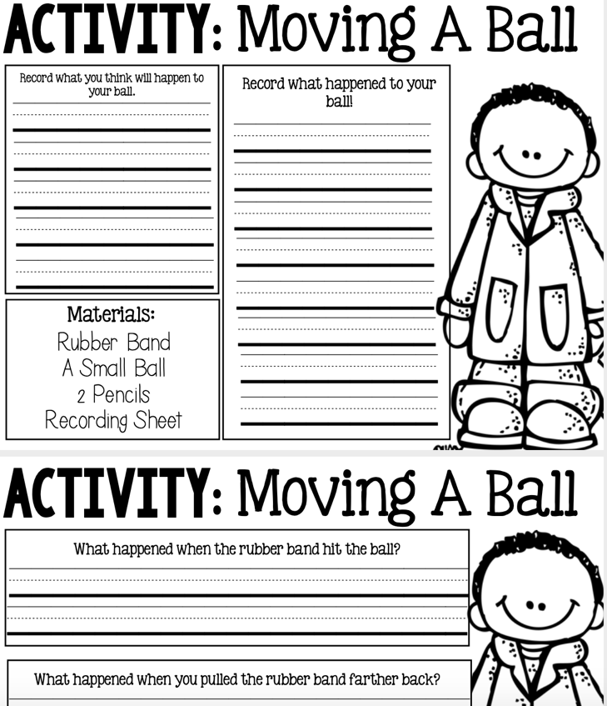
Closure: | We will have a class discussion on what the students observed and answer the questions from the worksheet.

Lesson 2
Name &Time (Minutes Allotted): | Hopper Popper – 45 mins
Learning Standards: Curricular Competencies | - Compare observations with those of others  - Communicate observations and ideas using oral or written language, drawing or role play  - Safely manipulate material to test ideas and predictions  - Ask questions about familiar objects and events
Learning Standards: Content | Types of Forces
Instructional Objectives | I can explain what motion is being used for the hopper  I can demonstrate my understanding of push and pull
Assessment: | Worksheet competed through the activity, participate in class discussions and observation
Teaching Strategies: | Writing instructions on the board, going through unknown vocabulary, walking around the classroom during activity time
Materials: | Worksheet  Launch pad printout  Pen  Rulers  Scissors  Rubber bands  Cardboard
Lesson Activities:
Introduction/Hook: | We will review what we leant about force, push, and pull.  We will watch the tug of war video from mystery science. After watching the video, we will discuss the following questions: Can you think of any way for your team to win? Is there something you could do to make it harder for the adults’ team to pull?
Body: | For our activity we will create hopper popper individually but as a class. Once our hopper popper is completed, we will work in groups of 2-3 and we will work on our high hop scorecard. They will try different methods to get the hopper to launch the highest they can. They will record what worked and what didn’t work.
Closure: | We will discuss as a class how high each group got, what made the hopper go high and what made the hopper go low. The students will take turns discussing their learning

Lesson 3
Name &Time (Minutes Allotted): | Bridge challenge - 45 mins pt.1
Learning Standards: Curricular Competencies | - Observe objects and events in familiar context  - Ask questions about familiar objects and events  - Make simple predictions about familiar objects and events  - Make and record observations  - Safely manipulate material to test ideas and predictions  - Make and record simple measurements using informal or nonstandard methods  - Compare observations with predictions through discussion  - Identify simple pattern and connections  - Compare observations with those of others  - Communicate observations and ideas using oral or written language, drawing or role play  - Generate ideas from experiences and interests  - Making: Use trial and error to make changes, solve problems or incorporate new ideas from self or others  - Use material, tools, and technologies in a safe manner in both physical and digital environments  - Develop their skills and add new ones through play and collaborative work
Learning Standards: Content | Types of Forces
Instructional Objectives | I can demonstrate understanding of push and pull forces
Assessment: | Observation- group work
Teaching Strategies: | Writing instructions on the board, going through unknown vocabulary, walking around the classroom during activity time. Provide examples
Materials: | Paper  Hardcover books  Rulers  Scissors  Pennies (or similar)
Lesson Activities:
Introduction/Hook: | We will work on the mystery science bridge activity. We will watch the bridge design video and discuss the questions.
Body: | The first day will be students getting into their groups and gathering the material and having hands on experience with creating bridges. They will not receive the pennies as that will be the second day. But this lesson will just be for them to get an idea of how to build a bridge and think of ideas for the final design. They can draw the design so they remember what they would like to do for the next lesson.
Closure: | We will discuss what the student’s designs are so other students can gather ideas

Lesson 4
Name &Time (Minutes Allotted): | Bridge challenge – 45 mins pt. 2
Learning Standards: Curricular Competencies | - Observe objects and events in familiar context  - Ask questions about familiar objects and events  - Make simple predictions about familiar objects and events  - Make and record observations  - Safely manipulate material to test ideas and predictions  - Make and record simple measurements using informal or nonstandard methods  - Compare observations with predictions through discussion  - Identify simple pattern and connections  - Compare observations with those of others  - Communicate observations and ideas using oral or written language, drawing or role play  - Generate ideas from experiences and interests  - Making: Use trial and error to make changes, solve problems or incorporate new ideas from self or others  - Use material, tools, and technologies in a safe manner in both physical and digital environments  - Develop their skills and add new ones through play and collaborative work
Learning Standards: Content | Types of forces
Instructional Objectives | I can demonstrate understanding of push and pull forces
Assessment: | Observation, worksheet to see if completed and how many pennies they were able to put on. Group work observation.
Teaching Strategies: | Writing instructions on the board, going through unknown vocabulary, walking around the classroom during activity time. Provide examples
Materials: | Paper  Hardcover books  Rulers  Scissors  Pennies (or similar)
Lesson Activities:
Introduction/Hook: | We will review what we learnt about bridges and force. We will discuss what groups have in mind to create their paper bridge. We will review the rules for the bridge challenge
Body: | Students will go into their groups with the materials and a worksheet. They will create 3 bridges. Draw the design then work on the worksheet. For each bridge design that they create they must see how many pennies (or equivalent) their bridge can hold. They can create 3 different designs to see which is the strongest and record the outcomes
Closure: | We will do a walk around to see the different groups designs of which was the strongest bridge.

Lesson 5
Name &Time (Minutes Allotted): | Exploring Speed -45 mins
Learning Standards: Curricular Competencies | - Make and record observations  - Make and record simple measurements using informal or nonstandard methods  - Compare observations with predictions through discussion  - Identify simple pattern and connections  - Compare observations with those of others
Learning Standards: Content | Types of forces
Instructional Objectives | I can explain what speed is
Assessment: | Observation, worksheet
Teaching Strategies: | Writing instructions on the board, going through unknown vocabulary, walking around the classroom during activity time. Provide examples. While outside having boundaries of the area we will be in
Materials: | Book: tortoise and the hare  Multiple stopwatches  Worksheet
Lesson Activities:
Introduction/Hook: | I will show some photos of some animal and ask the students which is faster? What does speed mean? We will read the book tortoise and the hare. We will do a book walk first about the book to predict what the story may be about. After the book we will talk about speed and the meaning of speed. How can we change how fast or slow something moves? Soccer ball for example. If we kick is lightly it was move slow, if we kick it harder it will move faster.
Body: | For our activity we will go outside (or gym) and compete our exploring speed worksheet  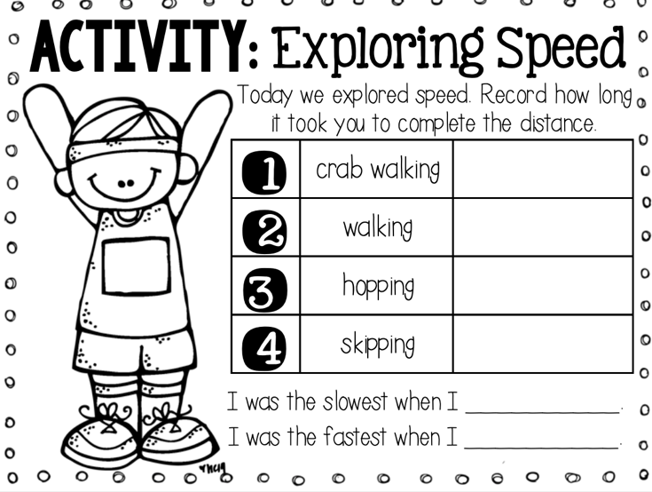  We will have a start and stop line and the students will have stop watches and record how long their partner takes to get to the other side while doing the specific actions.
Closure: | We will discuss what the slowest movement was and what the fastest movement was. And in general, what the fastest time was for speed.

Lesson 6
Name &Time (Minutes Allotted): | Blow painting
Learning Standards: Curricular Competencies | - Create artistic works collaboratively and as an individual using ideas inspired by imagination, inquiry, experimentation, and purposeful play  - Demonstrate increasingly sophisticated application and/or engagement of curricular content  - Communicate observations and ideas using oral or written language, drawing or role play  - Use material, tools, and technologies in a safe manner in both physical and digital environments  - Develop their skills and add new ones through play and collaborative work  - Compare observations with those of others
Learning Standards: Content | - Types of forces  - Processes, materials, technologies, tools and techniques to support arts activities  - Personal and collective responsibility associated with creating, experiencing, or sharing in a safe learning environment
Instructional Objectives | I can create an art piece by using forces and motion
Assessment: | Observation, different techniques used in their art
Teaching Strategies: | Writing instructions on the board, walking around the classroom during activity time. Provide examples
Materials: | Paint  Spoon or dropper  Straw  Thicker paper  examples
Lesson Activities:
Introduction/Hook: | Stand in front of the class and start blowing bubbles, ask the students what I am doing. Get them to realize that this is a force, and I am pushing the bubble out of the wand with my breath. similar what we will be doing for art. If I blow hard, I get no bubble. If I blow softly, I will get a large bubble.
Body: | Students will drip a small amount of paint onto their paper. Using a straw, they will blow on the drops of paint to make a design. Questions to think about before and during the activity is what will happen to the paint if you blow at it differently? Softer, harder, longer exhalations and short? What are different methods we can use; are we using push forces or pull forces? Students are encouraged to try different methods to see how their art will turn out.  Extension: move wet paint around the paper using gravity (could be after wee learn about gravity)
Closure: | We will discuss what methods the students preferred for their artwork

Lesson 7
Name &Time (Minutes Allotted): | Gravity Intro – 45 mins
Learning Standards: Curricular Competencies | - Observe objects and events in familiar context  - Ask questions about familiar objects and events  - Make simple predictions about familiar objects and events  - Make and record observations  - Safely manipulate material to test ideas and predictions  - Make and record simple measurements using informal or nonstandard methods  - Compare observations with predictions through discussion  - Generate ideas from experiences and interests  - Making: Use trial and error to make changes, solve problems or incorporate new ideas from self or others  - Use material, tools, and technologies in a safe manner in both physical and digital environments  - Develop their skills and add new ones through play and collaborative work
Learning Standards: Content | Type of forces
Instructional Objectives | I can explain and demonstrate that gravity is a force that pulls things towards the ground
Assessment: | Observation, class discussion
Teaching Strategies: | Writing instructions on the board, going through unknown vocabulary, walking around the classroom during activity time. Provide examples
Materials: | Cardboard  Ball  Worksheet
Lesson Activities:
Introduction/Hook: | Watch this video as an intro to gravity. https://www.youtube.com/watch?v=suQDwZcnJdg&ab_channel=PeekabooKidz  https://www.youtube.com/watch?v=ljRlB6TuMOU&ab_channel=CrashCourseKids  We will discuss the definition of gravity, what it means, where have the students heard the term gravity before etc. Just get an understanding of what the students already know. We can demonstrate gravity. Dropping items on the floor. Why does it go down but not up? Bring in a yoyo or watch a video of yoyo for gravity example
Body: | For our activity we will be testing our gravity using ramps. Students will get a flat piece of cardboard and they will create their own ramps (put it against their water bottle, pencil box etc)
Closure: | We will go around the classroom and do a gallery walk of the different incline’s groups have used

Lesson 8
Name &Time (Minutes Allotted): | Magnets 45 mins
Learning Standards: Curricular Competencies | - Observe objects and events in familiar context  - Ask questions about familiar objects and events  - Make simple predictions about familiar objects and events  - Make and record observations  - Safely manipulate material to test ideas and predictions  - Make and record simple measurements using informal or nonstandard methods  - Compare observations with predictions through discussion  - Generate ideas from experiences and interests  - Making: Use trial and error to make changes, solve problems or incorporate new ideas from self or others  - Use material, tools, and technologies in a safe manner in both physical and digital environments  - Develop their skills and add new ones through play and collaborative work
Learning Standards: Content | Types of Forces
Instructional Objectives | I can explain that a magnet is an object that uses force
Assessment: | Worksheet, objects are placed in the correct spot
Teaching Strategies: | Writing instructions on the board, going through unknown vocabulary, walking around the classroom during activity time. Provide examples
Materials: | Worksheet  Video  Magnets – class set  Mystery objects
Lesson Activities:
Introduction/Hook: | Magnet trick! Ask students how is this trick possible? We will talk about magnets and what it is. Watch this video https://www.youtube.com/watch?v=yXCeuSiTOug&ab_channel=PeekabooKidz  I will have a mystery bag and we will predict whether or not it will magnetize or not as a class.
Body: | After class discussion students will have a worksheet 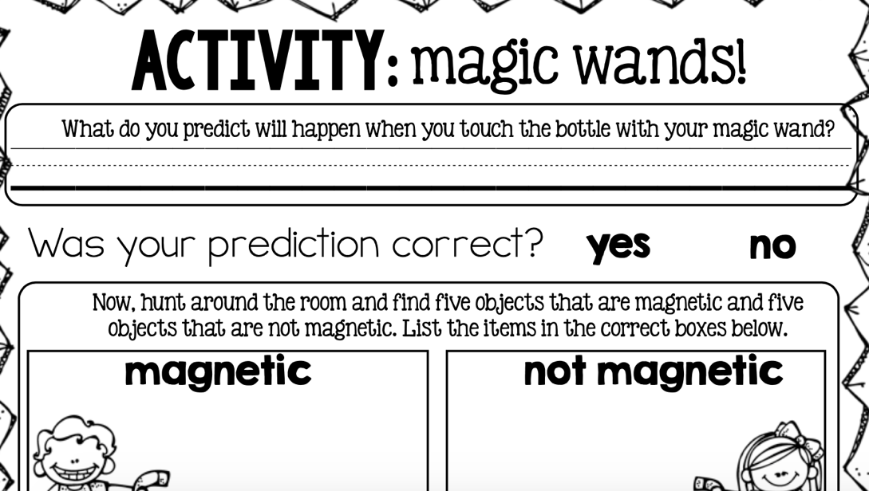  And their goal is to find 3-5 items for each box throughout the classroom
Closure: | We will meet back at the carpet and talk about what they found and if they were surprised by some items.

Lesson 9
Name &Time (Minutes Allotted): | Magnet pt 2
Learning Standards: Curricular Competencies | - Observe objects and events in familiar context  - Ask questions about familiar objects and events  - Make simple predictions about familiar objects and events  - Make and record observations  - Safely manipulate material to test ideas and predictions  - Make and record simple measurements using informal or nonstandard methods  - Compare observations with predictions through discussion  - Generate ideas from experiences and interests  - Making: Use trial and error to make changes, solve problems or incorporate new ideas from self or others  - Use material, tools, and technologies in a safe manner in both physical and digital environments  - Develop their skills and add new ones through play and collaborative work
Learning Standards: Content | Types of forces
Instructional Objectives | I can explain that a magnet is an object that uses force
Assessment: | Observation  Worksheet shows their learning/ understanding
Teaching Strategies: | Writing instructions on the board, going through unknown vocabulary, walking around the classroom during activity time. Provide examples
Materials: | Magnetic items  Nonmagnetic items  Pencil  Paper clips  Thread  Ring magnets
Lesson Activities:
Introduction/Hook: | will have a mystery bag and we will predict whether it will magnetize or not as a class. We will watch mystery science to learn about magnets
Body: | We will start experimenting with magnets, I want the students to first play around with the magnets to get an understanding of how they work and what materials stick to it. After, we will work on our mystery science worksheet about magnets.
Closure: | We will watch the last part of the video that concluded our magnet experiment, and we will discuss the worksheet outcome

Lesson 10
Name &Time (Minutes Allotted): | Big Little Science Centre Field Trip
Learning Standards: Curricular Competencies | - Make simple predictions about familiar objects and events  - Make and record observations  - Safely manipulate material to test ideas and predictions  - Make and record simple measurements using informal or nonstandard methods  - Compare observations with predictions through discussion  - Use sources of information and prior knowledge to make meaning  - Communicate using sentences and most conventions of Canadian spelling, grammar, and punctuations  - Use material, tools, and technologies in a safe manner in both physical and digital environments  - Develop their skills and add new ones through play and collaborative work
Learning Standards: Content | Types of Forces  Language features, structures, and conventions
Instructional Objectives | I can write about what I observed during our field trip
Assessment: | Observation during field trip  Journal entry, complete 3-4 sentences about what they learnt
Teaching Strategies: | Field trip guide- lots to prep prior  During journal entry, have some starting sentences/ ideas for students, or students can come up with starters and share with the class. Write them on the board for reference.
Materials: | Journals
Lesson Activities:
Introduction/Hook: | We will be going to the big little science center to sum up our learning about forces and motions. The first part of the field trip will be in the hands-on room. Students will be able to walk around and play with the hands-on activities.
Body: | We then will be joining a force and motions class where they will do a bunch of activities about what we have previously learnt.
Closure: | Once we are back from the field trip as a wrap up students will write a journal entry about what they learnt at the BLSC and something they enjoyed about the field trips

Extensions to Unit:
A lot of lessons can be broken down into 2 lessons. And we can have review days in between if needed ,as well as catch up days.

Reflections and Revisions

