Bachelor of Education (Elementary) &

Bachelor of Education (Secondary) STEM

Unit Plan Template

Unit Title: | Patterning | Number of Lessons | 9 | Time  (in weeks): | 3-4
Name: | Barkha Dhanju | Subject(s): | Math/Art/ Music/ Indigenous studies | Grade(s): | 2

Rationale
This unit is important as patterning allows students to predict what comes next. Patterning allows shape recognition. This unit incorporates patterning in not just math, but music and art. Students will be able to see how patterning fits into our everyday lives.

Overview:
In this unit we will begin by learning what repeating patterns are. We will learn how repeating patterns have different attributes and make our own repeating patterns with up to 2 attributes. We will work on repeating patterns in music and art. We are bringing in indigenous content by creating beaded bracelets that follow a repeating pattern. We will then focus on growing patterns with numbers. Like skip counting we will use a number line and figure out the number rule for the pattern. This is an introduction to increasing patterns as we then will introduce increasing patterns with shapes and colours. We will go into our playground and search for patterns and learn the different patterns that are around us. We will also create a mandala that shows off all the different patterns we have learnt throughout the unit.

CORE COMPETENCIES
Communication | Thinking | Personal & Social
- Students engage in informal and structured conversations in which they listen, contribute, develop understanding and relationships, and learn to consider diverse perspectives.  - Students communicate by receiving and presenting information.  - Present information for many purposes and audiences, and their presentations often feature media and technology.  - Students combine their efforts with those of others to effectively accomplish learning and tasks. | - Critical thinking  - Students learn to engage in inquiry when they identify and investigate questions, challenges, key issues, or problematic situations in their studies  - Students apply critical, metacognitive, and reflective thinking in given situations, and relate this thinking to other experiences, using this process to identify ways to improve or adapt their approach to learning  - Creative thinking  - Students get creative ideas that are novel and have value.  - Students may generate creative ideas through free play, engagement with other’s ideas, or consideration of a problem or constraint, and/or because of their interests and passions. | - Positive personal and cultural identity  - They are aware that learning involves patience and time.  - Personal awareness and responsibility  - They understand how what they value has been influenced by their life experiences.  - Students acknowledge their strengths and abilities, and they intentionally consider these as assets, helping them in all aspects of their lives.  - Social responsibility  - Students build and maintain diverse, positive peer and intergenerational relationships  - . They are aware and respectful of others’ needs and feelings and share their own in appropriate ways.  - They adjust their words and actions to care for their relationships.

BIG IDEAS
(multiple subject areas for integrated unit)
Subject Name Math | Subject Name Music | Subject Name Art
The regular change in increasing patterns can be identified and used to make generalizations | Dance, drama, music and visual arts are each unique language for creating and communicating | Creative expression develops our unique identity and voice

LEARNING STANDARDS
Curricular Competencies | Content
Math:  - Use reasoning to explore and make connections  - Model mathematics in contextualized experiences  - Develop, demonstrate, and apply mathematical understanding through play, inquiry and problem solving  - Visualize to explore mathematical concepts  - Connect mathematical concepts to each other and to other areas and personal interests  - Incorporate first people’s worldviews and perspectives to make connections | - Repeating and increasing patterns
Music:  - Explore elements, processes, materials, movements, technologies, tools and techniques of the arts | - Elements in the arts: beat, rhythm, pattern
Art:  - Explore personal experience, community and culture through arts activities  - Create artistic works collaboratively and as an individual using ideas inspired by imagination, inquiry, experimentation, and purposeful play | - Elements in the arts: pattern, color, repetition.  - Traditional and contemporary aboriginal arts

Prerequisite Concepts and Skills:
Prior shape knowledge
Skip counting will help
Sequencing will also help

Teacher Preparation Required:
Lesson # | Teacher Preparation Required (See Unit Plan Sample)
Lesson 1 | Storybook or read aloud  Patterning PowerPoint
Lesson 2 | Prepare worksheet and material, create a sample for students to use as a visual
Lesson 3 | Organize beads by colour  Have string cut prior and create a sample beaded bracelet
Lesson 4 | Have the YouTube video prepared and ready to go without the ads
Lesson 5 | Cut print and laminate the number cards for students so we are able to recuse them
Lesson 6 | Cut, print, and laminate the block cards.  Organize pattern blocks to bins so each group has a set
Lesson 7 | Do a walkthrough of the playground prior to see boundaries and where the best patterns are
Lesson 8 | Print worksheet  Ensure enough colouring crayons for entire class
Lesson 9 | Have mandala examples ready  Create a completed sample  Think of shapes ahead of time  Print out worksheet prior

Cross-Curricular Connections:
We will be focusing on math but incorporating art as we will be beading. Beading is a form of art from the indigenous community so we will be also learning about the significance of beading from an indigenous lens. We will also be using our pattern knowledge in music. We will be creating our own repeating rhythms and increasing rhythms. We will be doing activities within music that will help us understand patterns outside of math.

Aboriginal Connections/ First Peoples Principles of Learning:
Learning is embedded in memory, history, and story.
Learning involves patience and time.
Learning is holistic, reflexive, reflective, experiential, and relational (focused on connectedness, on reciprocal relationships, and a sense of place).

While creating this unit plan, I approached it with an indigenous lens. Rather than having the students sit at their desk and do worksheets I have students getting up and going outside to demonstrate their learning. Students are learning while playing. Students are also learning while creating indigenous art through beading. I have also incorporated storytelling within the unit. Each lesson has an indigenous focus whether it be indigenous knowledge or just by the FFPL

Universal Design for Learning (UDL)
For each lesson I have multiple means of representation. If it’s not within the lesson, we review the lesson multiple times in multiple ways for the students to see examples in different ways. We use multiple means of engagement within this unit and action. Students are able to demonstrate their learning in many different avenues. Whether it be a worksheet or colouring. Students are able to use blocks to show their learning as well. We have also integrated art and music into our math lesson which will motivate students who do not love math into learning.

Differentiated Instruction (DI):
My student cannot hear in one ear therefore we must wear a microphone on our neck while teaching all the time.

Overview of Lessons:

Lesson 1
Name &Time (Minutes Allotted): | 40 minutes
Learning Standards: Curricular Competencies | - Use reasoning to explore and make connections
Learning Standards: Content | - Repeating and increasing patterns
Instructional Objectives | Students will be able to choose the correct colour for the repeating pattern
Assessment: | Observation & participation in group activity.
Teaching Strategies: | Clapping patterns to get students attention
Materials: | Storybook or read aloud  Patterning PowerPoint
Lesson Activities:
Introduction/Hook: | Start by getting the students attention with some clapping patterns. Create a few clapping patterns for them to follow. After a few and their attention is on me I will tell them to come to the carpet. I will ask students if they know that it’s called what I was clapping. Once someone says a pattern, I will let them know that we are learning about patterns in the math today.
Body: | We will read a book about patterns: https://www.youtube.com/watch?v=cdF8myME9Cc&ab_channel=Mrs.Kim%27sBuildingBlocks  And then we will work on a patterning PowerPoint slide show together. We will work as a classroom to complete the patterns.  (can’t attach the power point, here is an example slide)  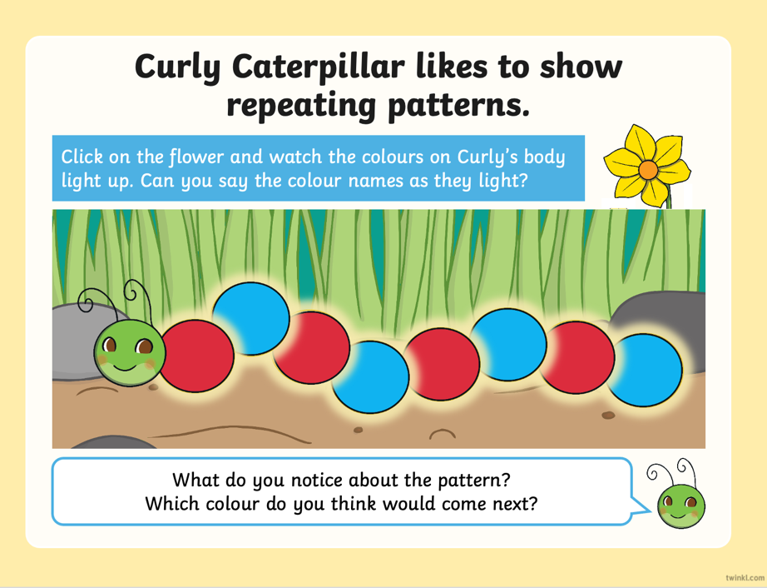
Closure: | After we finish the power point, I ask the students if they see any repeating patterns in our classroom.

Lesson 2
Name &Time (Minutes Allotted): | 40 Minutes
Learning Standards: Curricular Competencies | - Visualize to explore mathematical concepts
Learning Standards: Content | - Repeating and increasing patterns
Instructional Objectives | Students will be able to create repeating patterns with two attributes.
Assessment:
  Emerging | Developing | Proficient | Extending
  Student demonstrates initial understanding of the concept of repeating pattern. 1/3 patterns are repeating patterns but only 1 attribute | Student demonstrates a partial understanding of the concept of repeating pattern. All 3 are repeating pattern but only 1 attribute. | Student demonstrates complete understanding of repeating patterns by creating all 3 patterns with 2 attributes and 3 repeats. | Students demonstrates a sophisticated understanding of concepts by creating a repeating pattern with 3+ attributes
Teaching Strategies: | Ask students to explain their thoughts after they answer a mathematical question
Materials: | White board and markers  Pattern examples  Pattern paper  Glue sticks  Paper to glue pattern on
Lesson Activities:
Introduction/Hook: | I will draw patterns on the board. Some will be repeating patterns with 1 attribute, some will be no pattern at all. The last one will be a repeating pattern with two attributes.  I will ask the students if each pattern is a repeating pattern or not and we will go through each one. I will ask the student how they know it’s a repeating pattern and they will explain their thoughts.  Once we get to the last repeating pattern, I will explain how this is still a repeating pattern, but it has 2 attributes which are characteristics (shape, colour, size).  Once we finish going through the examples on the board, we will introduce the activity.
Body: | In pairs, students will receive sheets of paper that have pattern blocks on them. Their goal is to create 3 different repeating patterns with two attributes that are 3 repeats. Once they have shown me their three repeating patterns, they can glue it onto a long piece of paper and hand it in.
Closure: | Pairs can share 1 pattern that they created on the document camera for the class to see how everyone created different patterns.

Lesson 3
Name &Time (Minutes Allotted): | 45 mins
Learning Standards: Curricular Competencies | Incorporate First Peoples worldviews and perspectives to make connections to mathematical concepts  Visualize to explore mathematical concepts
Learning Standards: Content | Repeating and increasing patterns  Elements in the arts: pattern, color, repetition.
Instructional Objectives | Make connections between patterning and beading  Create a repeating pattern with beads
Assessment: | Can create a repeated pattern with beads.  3 different patterns
Teaching Strategies: | Organize beads by colour  Have string cut prior
Materials: | Youtube video: https://www.youtube.com/watch?v=aGyz6q-LHaU&t=70s&ab_channel=CBCKids  Pony beads- multiple colours  Cord or string  Samples of FN beadwork.
Lesson Activities:
Introduction/Hook: | Introduction (anticipatory set – “HOOK”):  We will begin by recapping some math concepts we learnt about patterning in the past  What is a patter, who gave give some examples of patterns. Draw some patterns on the board.  I will then share that we will be doing patterning in art today. We will be working with beads. To share the significance in beading within the indigenous community we will be watching this video: https://www.youtube.com/watch?v=aGyz6q-LHaU&t=70s&ab_channel=CBCKids
Body: | After watching the video, we will discuss what Warren shared with us. What was the significance of beading for him and what did he use beading for?  After, we have our discussion I will share the instructions for our art activity. The students will be able to choose different colour pony beads and they must create 3 different repeating patterns. They must first share the pattern on their desk and once they are able to display a repeating pattern, they can choose 1 pattern that they’ve created to put on string. Once they are ready to bead, they will be able to go get some string or cord and create a beaded bracelet. Before having the students go back to their desk, I will demonstrate how to use the string. If they need assistance with tying a knot on the end of the string, then I will be able to help them.
Closure: | Before clean-up we will have 3 volunteers to share the pattern they created with the beads, and they will share how it is a repeating pattern.  Once its clean up time we will put everything in individual envelopes in which we can work on later during another art class.

Lesson 4
Name &Time (Minutes Allotted): | 45 mins
Learning Standards: Curricular Competencies | - Explore elements, processes, materials, movements, technologies, tools and techniques of the arts
Learning Standards: Content | Elements in the arts: beat, rhythm, pattern
Instructional Objectives | Students will be able to create a repeating pattern with movement and sounds from body percussion within music
Assessment:
  Emerging | Developing | Proficient | Extending
  Student demonstrates initial understanding of the concept of repeating pattern. Pattern was not repeating | Student demonstrates a partial understanding of the concept of repeating pattern. Pattern was somewhat repeating | Student demonstrates complete understanding of repeating patterns by creating a pattern with different movements | Students demonstrates a sophisticated understanding of concepts by creating a repeating pattern with 3+ attributes
Teaching Strategies: | Pause the video if students are not on task.
Materials: | YouTube videos  Time clock
Lesson Activities:
Introduction/Hook: | We will begin by watching our first video and participating in it https://www.youtube.com/watch?v=2X8haXItkt4&ab_channel=MusicwithMrsMorgan  After watching the video, I will ask the students what they noticed about the video. I will lead them to answering it was a pattern. I will ask what kind of pattern? Repeating pattern with 2+ attributes. I will ask the students what patterns they noticed if they remember. We will discuss what they noticed and then before I begin the second video, I will ask them to look out for repeating patterns as I would like them to share what patterns they saw. I will also give them a debrief of the different movements we will be using throughout this song.  We will then play this video and follow along https://www.youtube.com/watch?v=kyUpZBVzD1I&ab_channel=MusicwithMrs.Kincaid  Once it is completed, we will discuss the different patterns we noticed.
Body: | It is now time for students to create their own movement pattern. They will get into pairs, and they will create their own repeating movement pattern. We will discuss what movements we can use as a reminder for students, and they can be creative and use new movements we have not used. The criteria will be do have a repeating pattern of 3 repeated with 4 different attributes. They will be able to choose their partners and once time is up, we will be presenting it to the class.
Closure: | After 20 minutes of creating patterns, the students will be in a circle, and we will share our repeating patterns.

Lesson 5
Name &Time (Minutes Allotted): | 35 mins
Learning Standards: Curricular Competencies | - Use reasoning to explore and make connections  - Develop, demonstrate, and apply mathematical understanding through play, inquiry and problem solving
Learning Standards: Content | Repeating and increasing patterns
Instructional Objectives | Students will be able to identify increasing patterns and what it is increasing by
Assessment: | Students are able to create increasing pattern their cue cards
Teaching Strategies: | Have material organized prior for easy transitions
Materials: | PowerPoint  Print out of patterns  Multiple sets of pattern blocks
Lesson Activities:
Introduction/Hook: | This will be review for most students  I will draw a few number lines one will go up by 5  The other 10 and the other 20 students must identify what each number line is increasing by
Body: | Students will be sent back to their desks and they each will receive a ziplocked baggie filled with cards. Their objective is to see the number pattern on the card. Identify the number pattern and find the matching card that has the number rule on it.  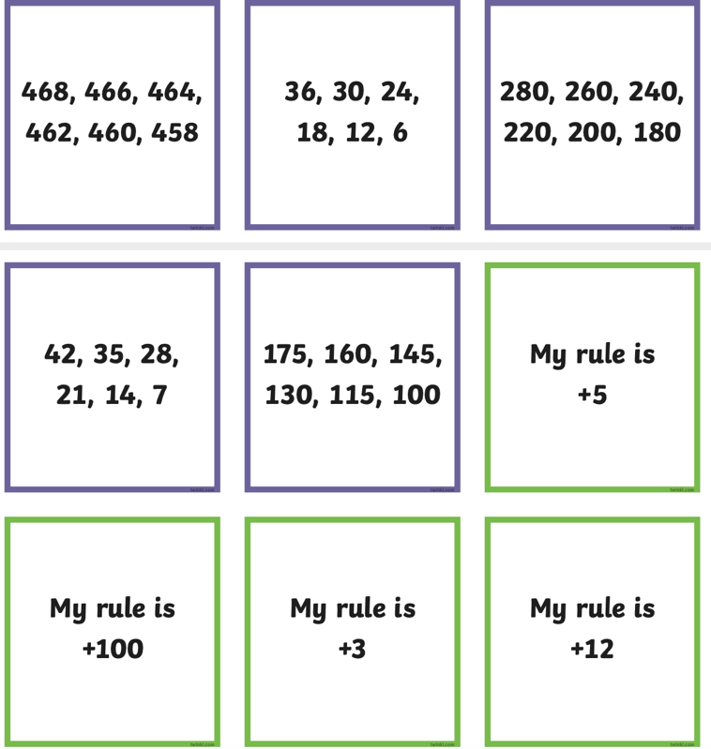  They must identify each rule and paper clip them together and put them in the baggie. And I will assess if most students are understanding the pattern rules or not as this will allow me to see if they remember increasing numbers from our past unit
Closure: | I will ask students to create their own increasing number pattern and other students must guess what the number rule is.

Lesson 6
Name &Time (Minutes Allotted): | 45 mins
Learning Standards: Curricular Competencies | - Develop, demonstrate, and apply mathematical understanding through play, inquiry and problem solving  - Visualize to explore mathematical concepts
Learning Standards: Content | Repeating and increasing patterns
Instructional Objectives | Students will be able to complete the increasing patterns with blocks
Assessment: | Observational assessment
Teaching Strategies: | Ensure there are enough building blocks prior to save time
Materials: | Power point  Building blocks  Cards cut out
Lesson Activities:
Introduction/Hook: | We will review the concept we learnt from last class of increasing patterns. We will have some number lines with number jumps, and I will ask students what the number rule is. After that we will being our PowerPoint that will teach us increasing patterns with shapes.  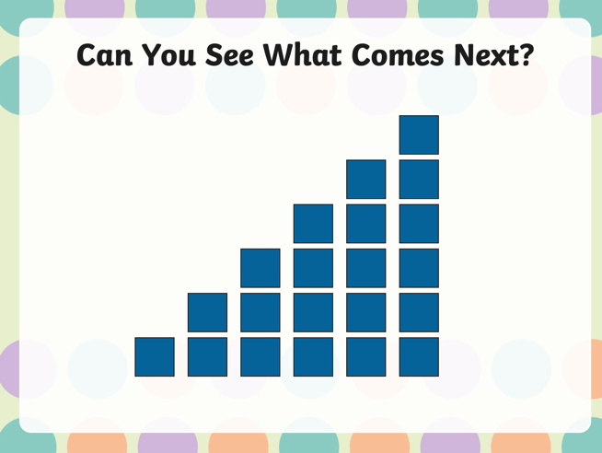  We will go through each slide and the students will show their learning by telling me what comes next in the pattern.  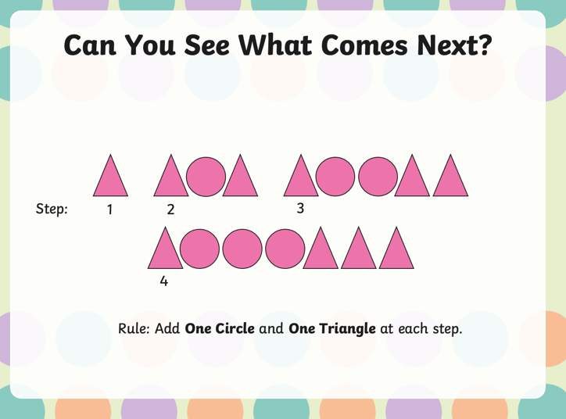
Body: | After we have gone through the PowerPoint and some examples, I will ask students if they have any questions about increasing patterns with shapes. They will then grab a bin full of blocks and share with their table and complete their own increasing patterns with the pattern cards provided.  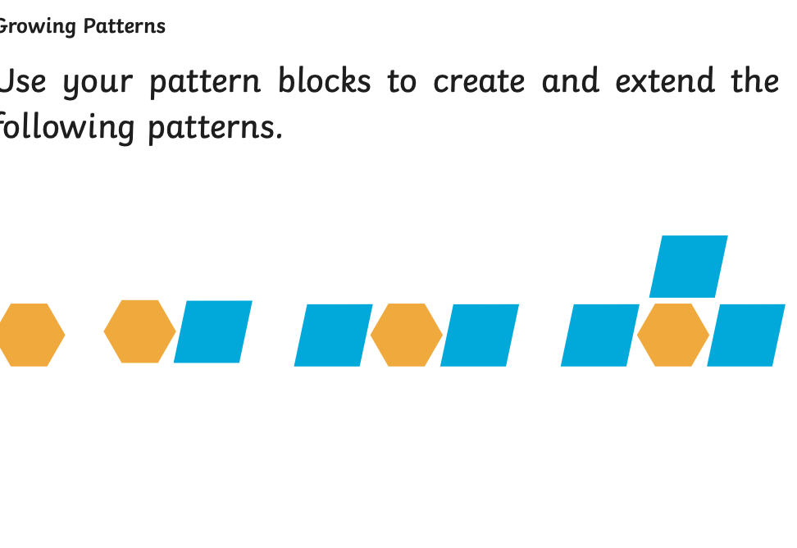  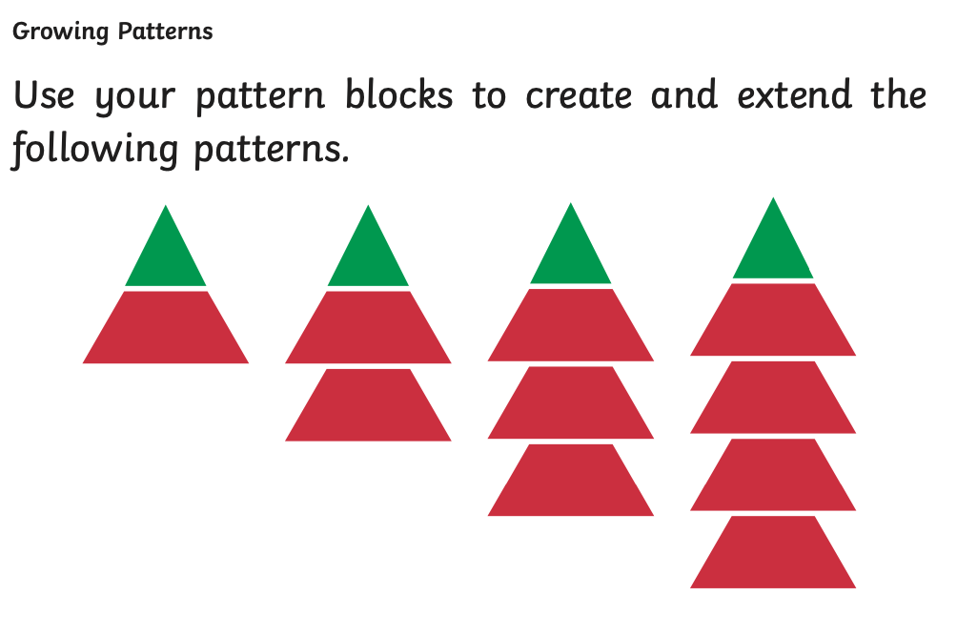
Closure: | After students have completed all the patterns and I have gone around and observed them at least once it will be time to clean up the blocks. Prior to cleaning up I will ask 3 students to draw an increasing pattern on the board and the students can guess what it is increasing by.

Lesson 7
Name &Time (Minutes Allotted): | 40 mins
Learning Standards: Curricular Competencies | - Develop, demonstrate, and apply mathematical understanding through play, inquiry and problem solving  - Visualize to explore mathematical concepts
Learning Standards: Content | Repeating and increasing patterns
Instructional Objectives | Students will be able to relate increasing patterns or repeating patterns to the everyday world
Assessment: | Presents their findings and explain their thoughts
Teaching Strategies: | Go over the rules before we set the students free in the playground. Must stay within the boundaries
Materials: | Paper  Marker  Power point
Lesson Activities:
Introduction/Hook: | I will have a PowerPoint of photos and the students have to tell me if they see a pattern, and what kind of pattern. We will go through a few of these photos. After, I will ask what the photos were of? And the conclusion is these patterns are a part of our everyday lives. And there are patterns all around us
Body: | Our task will be to go outside and find a pattern. Once the pair finds a pattern, they must draw out what they see. We will come back inside, and each pair will present the pattern they found outside, where they found it and what kind of pattern is it.
Closure: | Each pair will explain their findings.

Lesson 8
Name &Time (Minutes Allotted): | 35 mins
Learning Standards: Curricular Competencies | - Use reasoning to explore and make connections
Learning Standards: Content | Repeating and increasing patterns
Instructional Objectives | Students will be able to demonstrate an understanding for increasing patterns
Assessment: | Increasing patterns worksheet
Teaching Strategies: | Walk around the classroom to observe while doing the work
Materials: | White board markers  Worksheet  Colouring material
Lesson Activities:
Introduction/Hook: | We will review what we have learnt so far with increasing patterns. I will ask students to come to the board and draw some examples and we will guess what the pattern rule is.
Body: | Students will work on a worksheet about increasing pattern rules. Once they have completed the worksheet, they will begin to color the patterns according to the pattern rule.  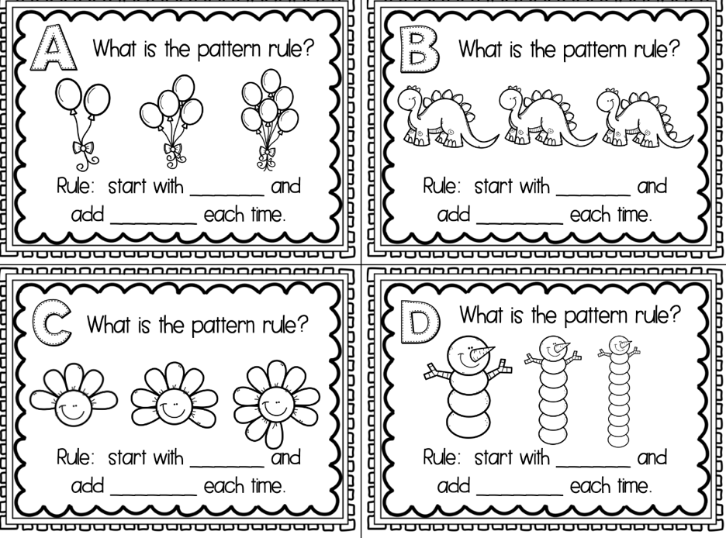
Closure: | Students exit ticket will be to draw their own increasing pattern on the back of the worksheet

Lesson 9
Name &Time (Minutes Allotted): | 45 mins
Learning Standards: Curricular Competencies | Create artistic works collaboratively and as an individual using ideas inspired by imagination, inquiry, experimentation, and purposeful play
Learning Standards: Content | Elements in the arts: pattern, color, repetition.
Instructional Objectives | Students will be able to complete a mandala using different patterns learnt in this unit.
Assessment:
  Emerging | Developing | Proficient | Extending
  Student demonstrates initial understanding of the concept of repeating and increasing patterns in their mandala. No true pattern is shown or very basic pattern | Student demonstrates a partial understanding of the concept of repeating pattern and increasing patterns in their mandala. A pattern has been attempted but is not completed | Student demonstrates complete understanding of repeating patterns and increasing patterns in their mandala. Both patterns are represented within the mandala | Students demonstrates a sophisticated understanding of concepts by creating a repeating pattern and increasing patterns in their mandala.
Teaching Strategies: | Have examples for students to look at for ideas and a list of shapes they can use
Materials: | Pictures of mandalas  Mandala template  Pencil  Paper  Pencil crayons
Lesson Activities:
Introduction/Hook: | We will look at some mandala art and I will ask the students what shapes they see and to point of some patterns they see as well. We will discuss the shapes and patterns in each mandala. We will go over different shapes students have learnt in the past for them to create their own mandala
Body: | Students will create their own mandala using shapes and patterns learnt in the class. We will then colour our mandalas using patterns as well.
Closure: | Students will cut out their mandalas and we will place them on the windows for everyone to see the different mandalas created

Resources:
Resources are all linked in the individual lessons

Extensions to Unit:
This unit will continue onto adding and subtracting patterns. A lot of the lessons will be 2 lessons as they are a lot of work to fit into one lesson.

Reflections and Revisions

